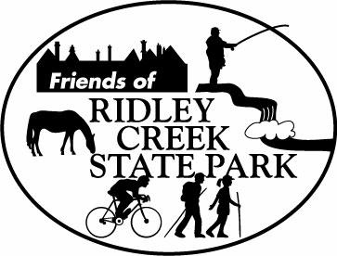
Media Contact: Pamela Cloud
Friends of Ridley Creek State Park
Sycamore Mills Road
Media, PA 19063
484-883-8231
pamcloud@kw.com

September 30, 2009

For Immediate Release

PHOTO CONEST

The time is closing in for The Friends of Ridley Creek Sate Park Annual Photo Contest! The amateur contest is open to children, teen and adults who have taken photos in Ridley Creek State Park in Edgmont, Delaware County.

Deadline for entries is October 31st . Winners will be recognized with cash prizes at the awards ceremony at Hunting Hill Mansion on Sunday, November 8th. Do you have a favorite place in the park you would like to share with others?

“Our goal is to raise funds for and increase awareness of The Friends of Ridley Creek State Park, a nonprofit, volunteer group established to help maintain the Park. Public support in the past has been terrific,” said Carol Rubin, organizer of the event. Even if you are not submitting a photo, please come in off the trail for a refreshment and tour of the gorgeous mansion, which as recently been improved with a bridal dressing room and other updates.

For more information and submission requirements, go to http://friendsofrcsp.org/contest09/ or call 610-565-3877.

Ridley Creek State Park provides a unique link to our area’s heritage, with beautiful open space in our community, recreation and educational opportunities. The Friends of Ridley Creek State Park was established as an independent, nonprofit organization for the purpose of preserving, protecting, restoring and enhancing the beauty and integrity of Ridley Creek State Park.

